How to setup and run the Scheduled Catalogue Scraper (Docker)
- Ensure Docker is installed and running!
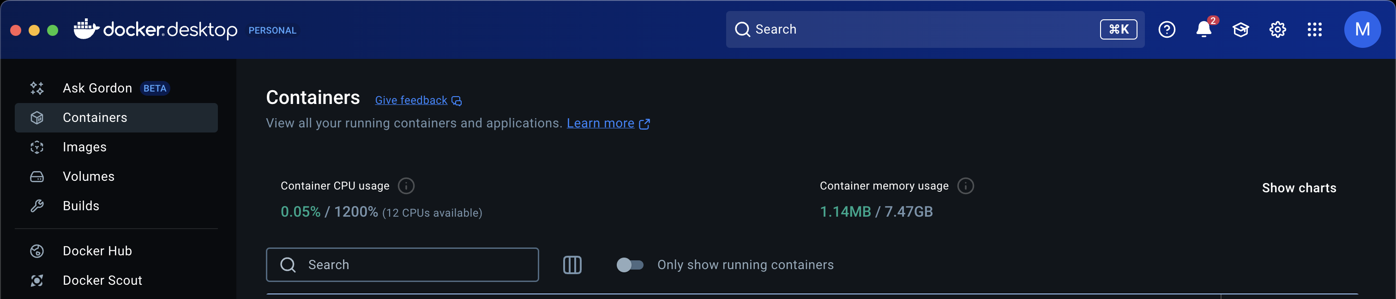
- Navigate to the Catalogue Scraper Folder
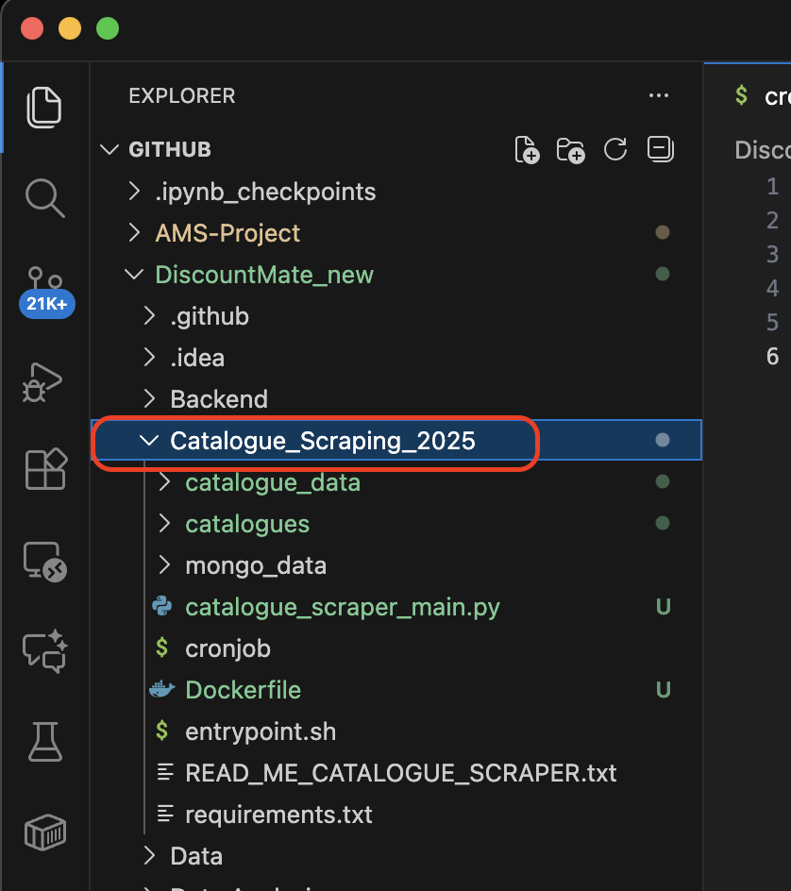

- Run the terminal command
docker build --no-cache -t catalogue-scraper .

- Run the terminal command
docker run -d \
--name catalogue-scraper \
-v "$(pwd)/catalogue_data:/app/catalogue_data" \
-v "$(pwd)/catalogues:/app/catalogues" \
catalogue-scraper

- Check the container is running and no errors
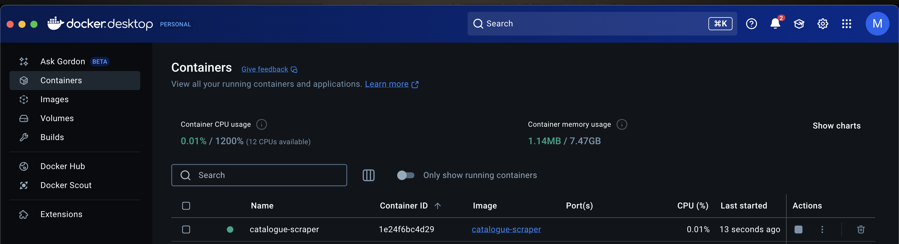

- Check the logs and watch for them to run.
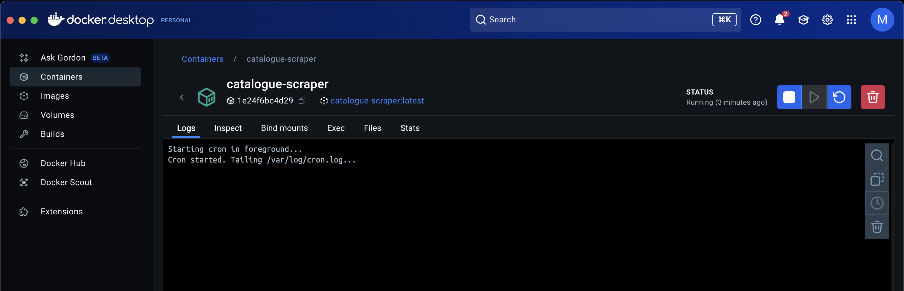

- Once the scheduled job runs. You will see active logs in docker logs tab, and the catalogues should start appearing in folder.
